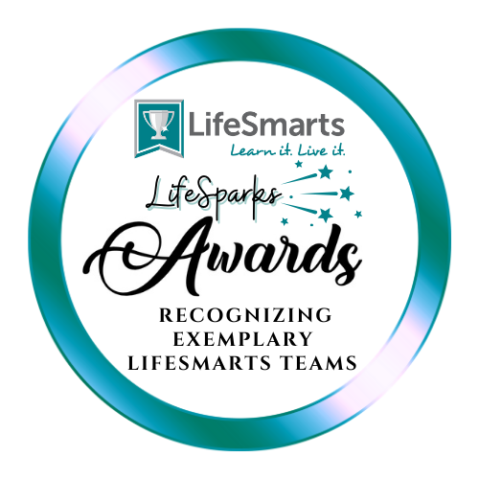
2026 LifeSmarts LifeSparks Team Awards
The LifeSmarts LifeSparks Award was established in honor of the 30th Anniversary of LifeSmarts in 2024.
The LifeSmarts LifeSparks Award annually recognizes exemplary LifeSmarts Teams for their participation in LifeSmarts. All LifeSmarts teams are invited to participate in this annual recognition program. Teams will be honored for active participation; demonstrating and sharing exceptional knowledge in all LifeSmarts topics, including Consumer Rights & Responsibilities, Personal Finance, Technology & Workforce Preparation, Health & Safety, and the Environment; and going above and beyond in the community.
A “spark” is something very special that creates a burst of activity. According to Search Institute, sparks are interests or passions that light a fire in a person's life. The term “spark” expresses the core of who a person is and how they want to engage with the world around them. Sparks bring joy and hope.
Over the past few years, the Search Institute asked over 7,000 kids what gives them joy and energy. Their sparks fit into five categories: leading, learning a subject matter, service to the globe, being active and the creative life.
All teams that gain 35 credits throughout the 2025-26 program year will be recognized with this year’s LifeSmarts LifeSparks Awards.
Teams do not have to compete in either the Varsity or Junior Varsity National LifeSmarts Championships to earn this honor. Use the LifeSparks scorecard to map out your team’s winning strategy to reach 35 credits by March 31, 2026.
Fill out the points application here (link coming) prior to the April 5th, 2026 deadline. Show your LifeSparks and be recognized for your exemplary participation in LifeSmarts.
Questions? Reach out to Cheryl (Cherylv@nclnet.org).

Scorecard to Earn the LifeSmarts LifeSparks Award in 2026
*Designates an activity may be done more than once
Activity | Eligible Teams | Timeframe | Credits | Our group and any required information
PARTICIPATION
*Coach creates a Varsity or JV team of 5 or more students. List names of teams, school or org and state. | All LifeSmarts teams | September 1, 2025 – March 31, 2026 | 1 each  (up to 5)
*5 or more team members complete competition quizzing. List names of teams that completed quizzing. | All LifeSmarts teams | September 1, 2025 – March 1, 2026 (ending dates vary) | 1 each  (up to 5 teams)
Team applies for a Meta Wild Card spot or a Varsity Wild Card spot (if available).  List name of team. | All Varsity LifeSmarts teams | December 5, 2025 or Jan. / Feb. date if applicable | 5
*Coach or team member teaches LifeSmarts U lesson in the classroom or for team practice. List name of lesson and presenter and number in audience. | All LifeSmarts teams | September 1, 2025 – March 31, 2026 (ending dates vary) | 1 each  (up to 5)
*Coach or team uses LifeSmarts in a Box activity in the classroom or for team practice. List name(s) of activity, date taught and number of participants | All LifeSmarts teams | September 1, 2025 – March 31, 2026 (ending dates vary) | 1 credit each (up to 5)
*Coach or team uses LifeSmarts Quest game in the classroom, club setting, with other groups, for team practice, etc. List name(s) of activity, date taught and number of participants | All LifeSmarts teams | September 1, 2025 – March 31, 2026 (ending dates vary) | 1 credit each (up to 5)
Varsity team competes at the state level | All Varsity teams | Dates vary | 5
Varsity team places in the State Competition | All Varsity teams | Dates vary | 5
JV team competes at the state level | All JV teams | Dates vary | 5
Junior Varsity team places in the State Competition | All JV teams | Dates vary | 5
JV team is invited to compete in JV National LifeSmarts Championship | All JV teams | * Actual event May 6-7, 2026, 2025. You may count your qualification or invitation | 5
Varsity Team is invited to Nationals as a Wild Card team or a Sweepstakes Team | All Varsity LifeSmarts teams | Feb. 28, 2025 | 5
Additional activities you would like us to consider (2 points each) | All teams | Provide name of activity, date of each activity, and number of participants | 2 per activity
KNOWLEDGE
4-H Summer Online Challenge | All 4-H teams | August 1 - 31. 2025 | 3
September TeamSmarts quiz | All LifeSmarts teams | September 1-30, 2025 | 3
FCCLA/LifeSmarts Qualifier Quiz | All FCCLA teams | October 20 – November 21, 2025 | 3
October TeamSmarts quiz | All LifeSmarts teams | October 1-31, 2025 | 3
FBLA LifeSmarts Fall Challenge | Any FBLA teams of 2 students | October 13 –November 7, 2025 | 3
November TeamSmarts quiz | All LifeSmarts teams | November 1-30, 2024 | 3
SkillsUSA Quiz Bowl Preparatory Quiz | SkillsUSA teams | October 1 - 31, 2025 | 3
SkillsUSA Health & Safety Challenge | SkillsUSA teams | November 1 – 29, 2025 | 3
December TeamSmarts quiz | All LifeSmarts teams | December 1-31, 2025 | 3
January TeamSmarts quiz | All LifeSmarts teams | January 1-31, 2026 | 3
BPA Technology & Workforce Preparation Challenge Quiz | BPA teams | January 1-31 2026 | 3
FBLA LifeSmarts Spring Challenge | Any FBLA teams of 2 students | January 26 – February 20, 2026 | 3
February TeamSmarts quiz | All LifeSmarts teams | February 1-28, 2026 | 3
BPA Personal Finance Challenge Quiz | BPA teams | February 1-28, 2026 | 3
FCCLA Spring Knowledge Bowl TeamSmarts Quiz | All invited FCCLA teams | March 1-31, 2025 | 3
Additional activities you would like us to consider (2 points each) | All teams | Provide dates of each activity, name of activity, how many students participated and any other pertinent information. | 2 per activity
ABOVE AND BEYOND
Team member serves on LEAP | All Varsity teams | August 1, 2025 – June 1, 2026 | 3
Coach nominates an outstanding senior for the Sarah Weinberg scholarship | All Varsity teams | Due March 15, 2026 | 3
*Community or other level Outreach event | All Varsity teams | September 1, 2025 – March 31, 2026. Provide dates of each activity, name of activity, how many students participated and any other pertinent information. | 3  (up to 4)
*Community fundraising event for your team | All Varsity teams | September 1, 2025 – March 31, 2026  Provide dates of each activity, name of activity, how many students participated and any other pertinent information. | 5  (up to 4)
*OTC medicine safety mentor presentation | All LifeSmarts teams | September 1, 2025 – March 31, 2026. Provide dates of each activity, name of activity, how many students participated and any other pertinent information. | 7(up to 2)
Pilot LifeSmarts lessons, participate in special project or pilot, pilot lessons for special project, etc. | All LifeSmarts teams | September 1, 2025 – March 31, 2026. Provide dates of each activity, name of activity, how many students participated and any other pertinent information. | 7 (up to 3)
Additional activities you would like us to consider (2 points each) | All teams | Provide dates of each activity, name of activity, how many students participated and any other pertinent information. | 2 per activity (up to 6)

Questions about points? Email Cheryl at Cherylv@nclnet.org

DUE APRIL 5, 2026!

