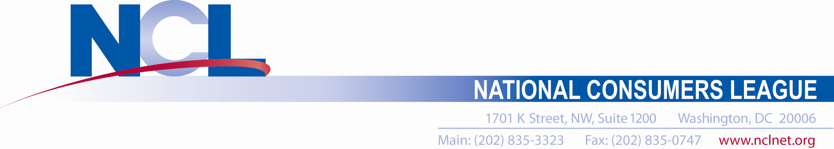
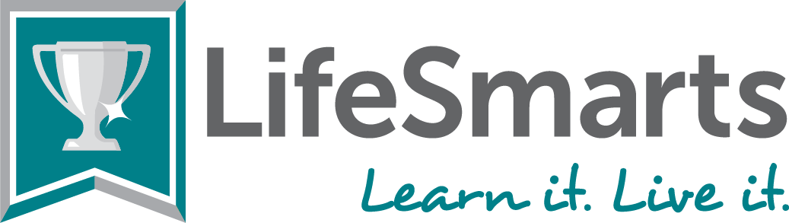
Date
Dear NAME,
Congratulations on having a team of students from your SCHOOL / ORGANIZATION competing in the 2025 National LifeSmarts Championship in Chicago, IL.
This team of students captured the STATE NAME LifeSmarts Championship (or Wild Card team Championship) earlier this year after many months of study and qualifying preliminary competitions. The team successfully fielded questions about real-life financial, consumer and marketplace issues and will now compete against 50 other teams from across the country for the 2025 National LifeSmarts Championship title.

LifeSmarts, a consumer education competition that challenges teens about personal finance, health & safety, the environment, technology & workforce preparation, and consumer rights & responsibilities, is a program of the National Consumers League (NCL). The competition prepares teens for their future and enables them to become successful, contributing citizens who are equipped with the life skills they need in today’s complex global marketplace. This is our 31st year of the LifeSmarts program.

This team of FOUR or FIVE students has been preparing since August, 2024 for the chance to represent our state and SCHOOL / ORGANIZATION to compete for scholarships and other awards in the National LifeSmarts Championship.
The students involved are: NAMES and GRADES (include schools if different schools and club or organization)
We appreciate your flexibility in allowing them to be away from school to attend this prestigious, educational event. We are requesting an excused absence for (FILL IN DATES –April 23-25, 2025), with the opportunity to make up any missed schoolwork. (adjust dates as needed for travel)
Please contact the team coach, NAME, EMAIL, PHONE if you have any questions. Thank you, in advance, for your support of these outstanding young people.
Sincerely,
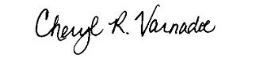
Cheryl Varnadoe
Program Director, LifeSmarts
National Consumers League

