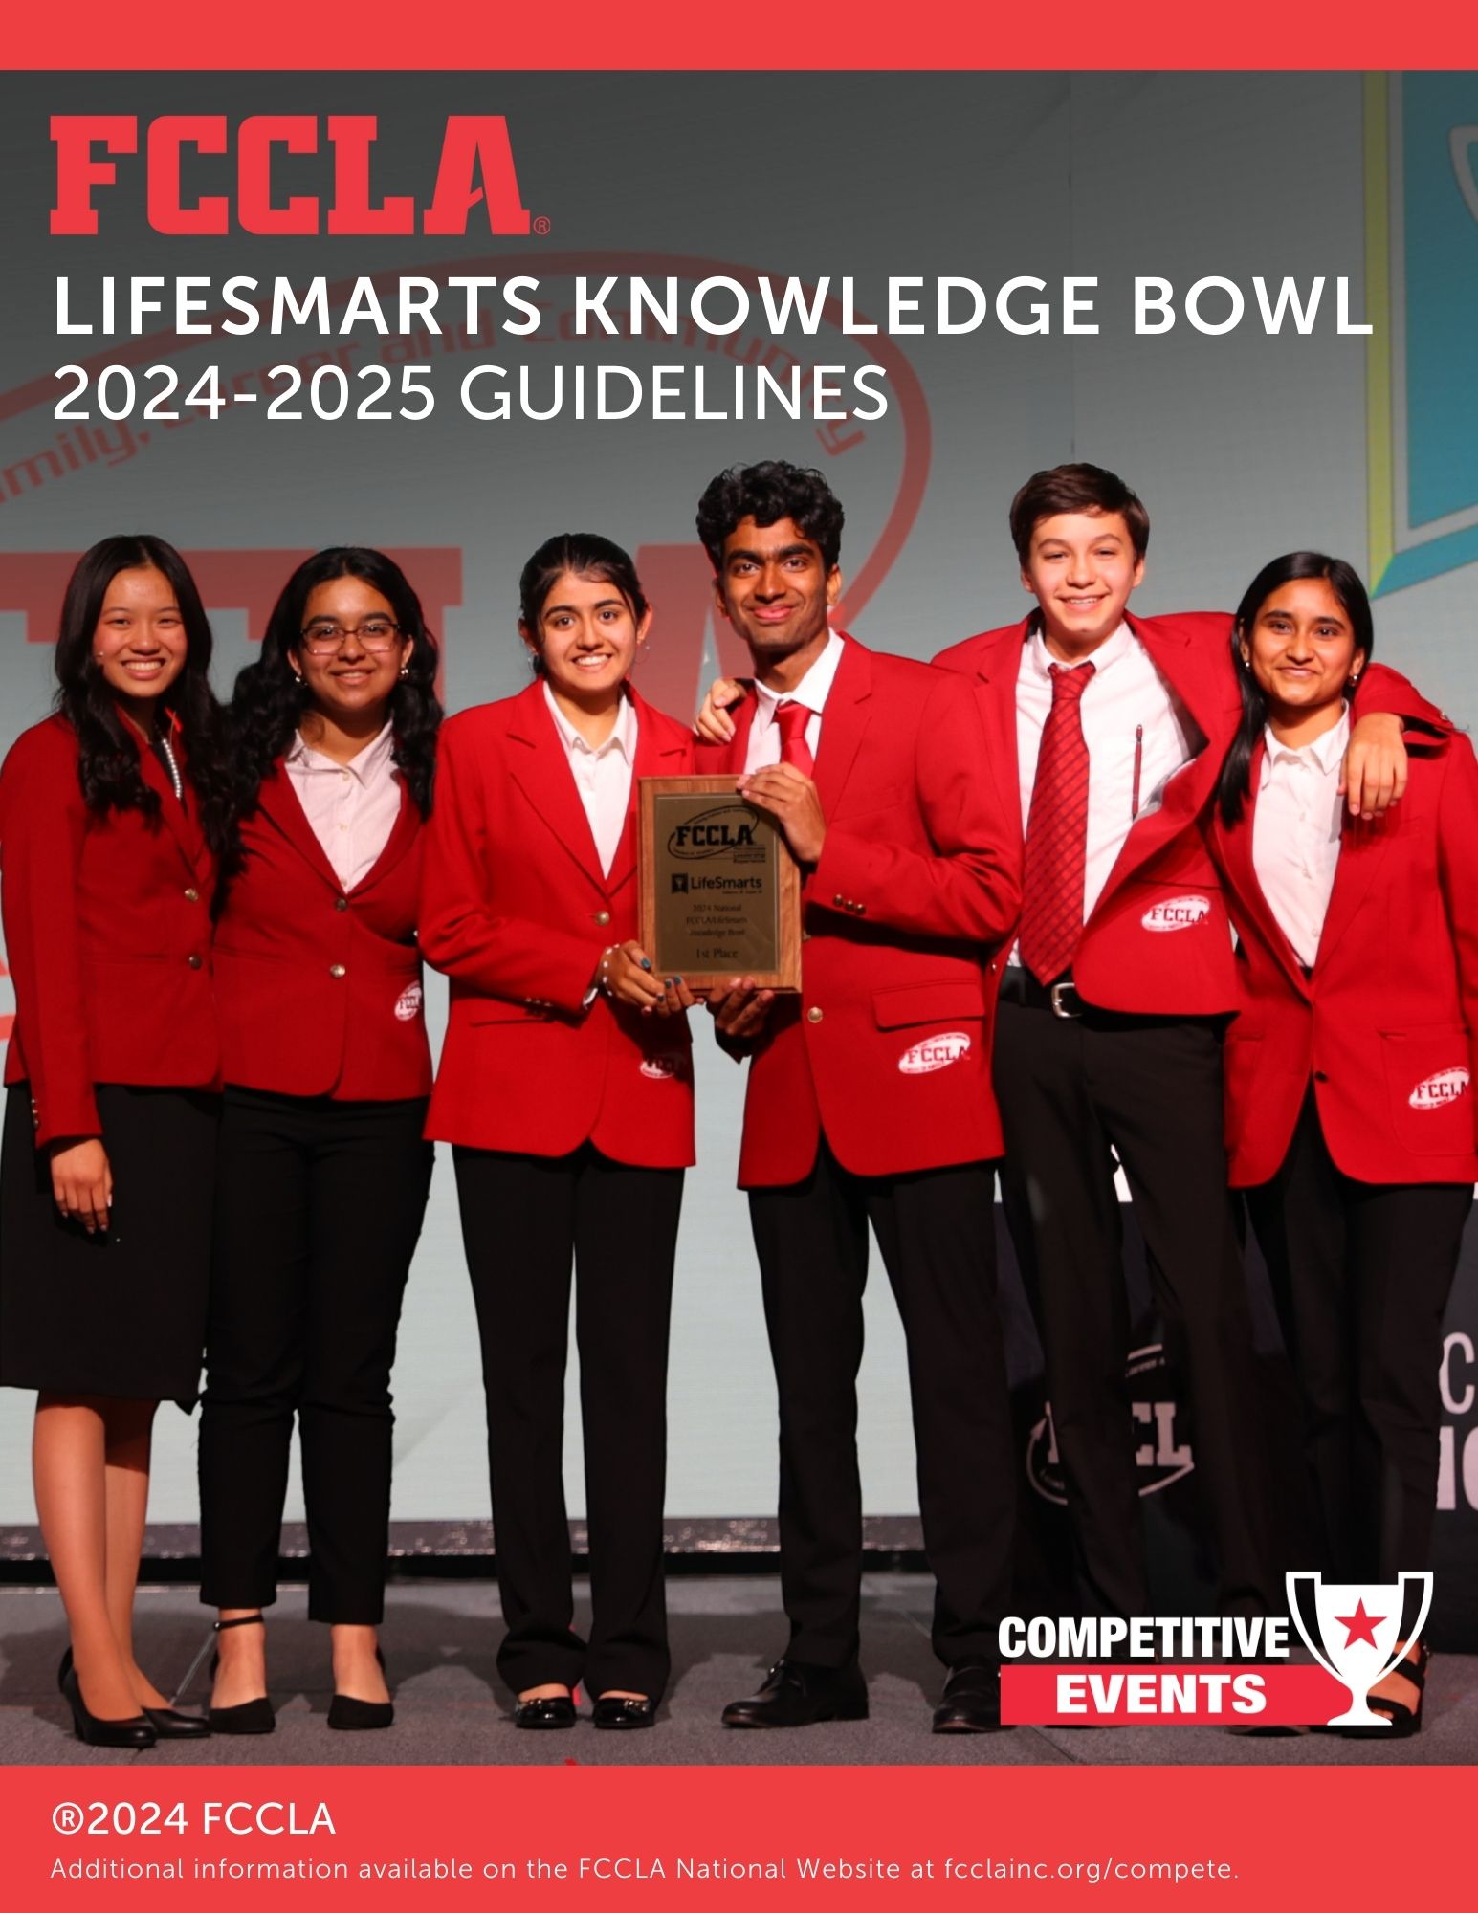**INSERT FRONT COVER PAGE**

**COMPONENTS**

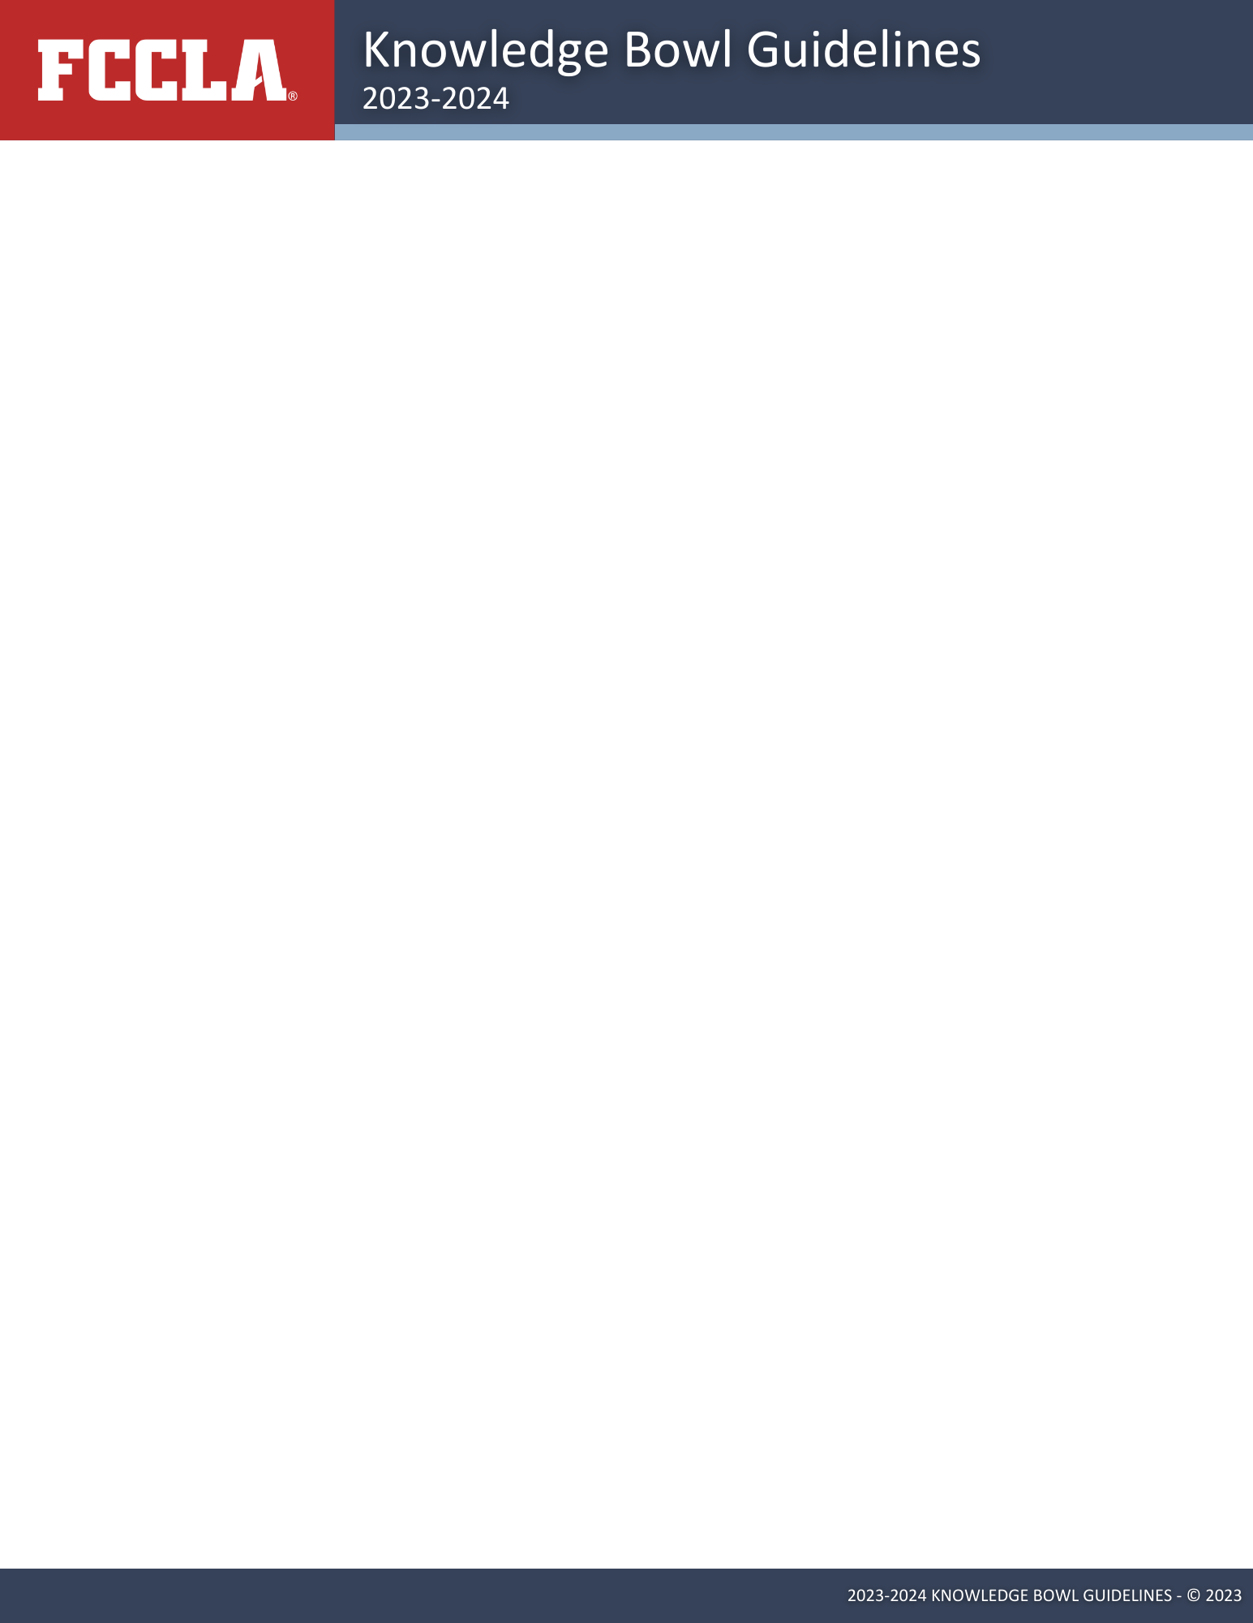

**The Ultimate Leadership Experience and The Ultimate Consumer Challenge - Combined!**

**Knowledge Bowl is a three-round team competition tests FCCLA members’ knowledge in the six content areas:**

1. Personal Finance
2. Consumer Rights & Responsibilities (to include Family, Career & Community Studies)
3. Technology (to include Fashion & Housing Design)
4. Health & Safety (to include Food Science & Nutrition and Early Childhood & Human Development)
5. Environment (to include Hospitality, Tourism & Recreation)
6. FCCLA Knowledge

**Dates and Deadlines**

It is the responsibility of all FCCLA members and advisers to review the National FCCLA Dates and Deadlines found on the [FCCLA website](http://www.fcclainc.org).

**VIEW NATIONAL DEADLINES**

**FCCLA/LifeSmarts Knowledge Bowl Components**

* Round 1-FCCLA Fall TeamSmarts NLC Qualifier Quiz
* Round 2-FCCLA Spring Knowledge Bowl TeamSmarts Quiz
* Round 3-Championship at National Leadership Conference

**TEAM COMPOSITION**

**Eligibility and Team Composition**

* Teams must be comprised of **five** affiliated FCCLA members (affiliated at both the state and national level in order to register to compete) from the same chapter. **Teams with less than five members are ineligible to compete.**
* Chapters may have more than one team.
* Team members may be mixed in grade levels.

**Preparation and Resources**

Questions come from a variety of sources. Preparation resources include resources found on the LifeSmarts website and in Family and Consumer Sciences textbooks, reference guides, content area websites, the FCCLA website, and other local or online resources.

**STUDY RESOURCES**

**Round 1 – FCCLA Fall TeamSmarts NLC Qualifier Quiz - October 21 – November 24, 2024**

All teams must be registered at https://lifesmarts.org and take the Fall TeamSmarts NLC Qualifier Quiz by November 24, 2024. Coaches and students should follow the directions at this page: [https://lifesmarts.org/lifesmarts-registration/.](https://lifesmarts.org/lifesmarts-registration/.%20)

All team members are expected to work together to take the FCCLA Fall TeamSmarts NLC Qualifier Quiz. If less than five members take the TeamSmarts Quiz, the team is ineligible to continue in competition. The TeamSmarts Quiz consists of 100 questions from the following content areas:

1. Personal Finance
2. Consumer Rights & Responsibilities (to include Family, Career & Community Studies)
3. Technology (to include Fashion & Housing Design)
4. Health & Safety (to include Food Science & Nutrition and Early Childhood & Human Development)
5. Environment (to include Hospitality, Tourism & Recreation)

These scores will be used to qualify the top 40 teams that will be invited to compete in the Championship at the National Leadership Conference.

**Round 2 – FCCLA Spring Knowledge Bowl TeamSmarts Quiz – March 1 – 31, 2025.**

All 40 teams that have qualified for the National Leadership Conference are required to participate in this quiz. Teams ranked 41 through 50 are also encouraged to take the quiz for practice, and their scores will be considered if these teams are selected as alternates. The quiz will feature a format similar to the Round I TeamSmarts quiz from the Fall but will include new questions. Teams do not need to re-register, as the quiz will automatically appear in the team captain’s quiz list. This quiz is an essential part of the Round 3 competition and serves as the first team score for the National Leadership Conference. It is important for teams to complete the quiz within the specified period and ensure that the team captain has access to it.

**Round 3: Championship at National Leadership Conference**

Competitors attending the National Leadership Conference must register to attend the entire conference and stay within the official meeting/conference hotel block for the length of the conference. If there are extenuating circumstances, a written waiver may be submitted via the State Adviser to National staff for consideration.

40 teams will qualify for the National Championship from the Fall TeamSmarts NLC Qualifier Quiz. Alternates will be selected based upon scores from the Fall TeamSmarts NLC Qualifier Quiz. The top 40 teams must confirm National Championship participation by **February 1** by completing the **RSVP Form**. We also ask that teams 41-50 also complete the RSVP form so we can contact alternatives if a top 40 team can no longer attend.

**Orientation and Pool Play**

Teams are assigned to one of five competition pools in either the *Morning or Afternoon Competition Session* based upon the Round 2 FCCLA Spring Knowledge Bowl TeamSmarts Quiz. Each pool will have 20 teams and each team will play three matches. The Round 2 TeamSmarts Quiz score plus the scores from the three matches will be combined to determine the top teams from each pool. Pools will play simultaneously and the questions for each round will be the same in each pool. As space allows, teams may have to wait in a holding room. Matches will be adjusted if there are fewer than 40 teams participating.   
**Important:** *No Afternoon Session teams, advisers, chaperones, or other conference attendees from those competing chapters* are allowed to attend / observe the Morning Sessions. *Likewise, no Morning Session teams, advisers, or other conference attendees* from those competing chapters are allowed to attend / observe the Afternoon Sessions.

**Top Sixteen**

Once all Pool Play matches have finished, each team will have the following scores added together to form their final NLC Cumulative Score: Round 2 FCCLA Spring Knowledge Bowl TeamSmarts Quiz and the three matches played in Pool Play. The top 16 teams (Sweet 16) advance to the knockout rounds on Day 2. The team in each pool (which includes both morning and afternoon competition sessions) with the highest NLC Cumulative Score will automatically advance to the knockout bracket. The eleven remaining teams with the highest NLC Cumulative Scores will also advance to the knockout bracket. It is possible for more than one non-winning team from the same pool to qualify. Teams are seeded for knockout matches. Teams will be notified through the FCCLA conference app.

**Knockout Bracket**

The top sixteen teams will be seeded into a 16-team single elimination bracket. Winners advance through the bracket until the top two finalists are determined. The top two teams will compete in one final match during a general session to determine first and second place. The remaining teams will be ranked based on cumulative scores.

Each round will consist of two parts — Head-to-Head Individual Questions as well as Team Questions. In the Head to-Head round, one multiple choice question from Categories 1-5 will be asked, with up to two open ended bonus questions asked after each correct answer. Participants should sit in order, based upon their individual topic category. In the Team Questions part of the round, all questions are open ended and randomly assorted. Three questions will be asked in each of the categories except FCCLA Knowledge, which will have one question per round.

During the Head-to-Head round, questions will be asked in the following order:

1. Personal Finance
2. Consumer Rights & Responsibilities (to include Family, Career & Community Studies)
3. Technology (to include Fashion & Housing Design)
4. Health & Safety (to include Food Science & Nutrition and Early Childhood & Human Development)
5. Environment (to include Hospitality, Tourism & Recreation)

During the Team round, questions are open ended and randomly assorted. Of the 16 Team questions, there are guaranteed to be 3 questions from Categories 1-5 and 1 question from Category 6, FCCLA Knowledge. Anyone may buzz in to answer a Team Question, unless someone from that team has already given an incorrect response. If a participant gives an incorrect answer, the question is reread and asked to the other team.

**Head-to-Head Individual Questions Rules**Head-to-Head Individual Questions are multiple choice. Each team member is assigned a number corresponding to the category they have selected as their focus topic.

1. Personal Finance
2. Consumer Rights & Responsibilities (to include Family, Career & Community Studies
3. Technology (to include Fashion & Housing Design)
4. Health & Safety (to include Food Science & Nutrition and Early Childhood & Human Development)
5. Environment (to include Hospitality, Tourism & Recreation)

These questions are asked only to the student on each team with the corresponding number. After the question-and-answer choices are read to team members #1, whichever individual buzzes in first has 10 seconds to respond. The individual cannot confer with team members. Individuals may give the full answer or the letter (a, b, or c) associated with the answer. If the student gives a correct answer, their team is awarded 5 points, and the moderator will ask up to two additional bonus questions to that individual. A minimum of 5 and a maximum of 15 questions will be asked in this round. If the individual who has buzzed in cannot answer in the time allowed, or gives an incorrect answer, the opposing individual team member has 10 seconds to provide an answer.

If a member buzzes in before the entire question is read, the moderator will stop reading the question or answer choices. The individual must give an answer within 10 seconds. If the answer is incorrect, the moderator will re-read the question-and-answer choices to the corresponding student on the opposing team. This student will have 10 seconds to buzz in and provide a response.

If neither individual buzzes in within 10 seconds, or both members give incorrect answers, the moderator will give the correct answer.

If a student correctly answers the multiple-choice question, that student will be asked an open ended follow-up question. The team may discuss this question and the answer must be provided by the student who buzzed in. If the follow-up question is answered correctly, then a second open ended follow-up question will be asked to that student following the same procedures. Up to two follow-up questions may be asked after each multiple-choice question.

If either follow-up question is not answered correctly, the question set ends. The corresponding student on the other team will not get an opportunity to answer the follow-up questions. Play continues with the next set beginning with an Individual question asked to the student in the next position.

Each correct answer is worth 5 points. There is no deduction for incorrect answers.

This process is repeated for all team members.

Upon completion of the Head-to-Head part of the round, scores will be tabulated by the scorekeeper and announced by the moderator.

**Team Questions Rules**   
Questions in the Team Questions part of the round are open ended. The moderator will ask a question, and the first person to hit their button will have the opportunity to answer. These questions are open to all members on the team, though only one student per team may buzz in to answer each question.

A student may buzz in before the entire question is read. If this happens, the moderator will stop reading the question and will call on the student who buzzed in. The team name and / or the student’s number will be called and then they have 10 seconds to answer the question. The team may confer both orally and in writing until a team member buzzes in. Once the team has buzzed in, conferring must stop. Only the team member who buzzed in will be allowed to answer the question.

If an incorrect answer is given, the moderator will begin re-reading the question, and members from the other team may buzz in at any time. If no one buzzes in within 10 seconds after the question has been read, or both teams give incorrect answers, the moderator will give the correct answer.

Each correct answer is worth 10 points. There is no deduction for incorrect answers.

This process will continue through all 16 open ended questions. Upon completion of the team questions, scores will be tabulated and announced by the scorekeeper and moderator. If there is a winner, the winner will be announced. If there is a tie that must be broken, tie breaker questions will be read.

**Tie-Breaker Round Rules**

Tie-breaker questions are open ended, and are randomly selected from the six topic categories. Each correct answer is worth one point. There is no deduction for incorrect answers. The first team that buzzes in will have 10 seconds to answer. The team that wins the best of three tie-breaker questions will be declared the winner. If there is still a tie after a round of three tie-breaker questions, a second set of 3 questions will be used. After that, one “sudden death” tie-breaker question will be used.

**Acceptability of Answers**



Only the first answer from the team member who buzzes in and is recognized will be accepted. Only one team member may buzz in per question. The moderator will determine if the answer given by the competitor matches the correct answer. If there is a question about the acceptability of the answer, the moderator will consult with the room judge(s).

**Challenges/Appeals**

During the team round of a buzzer match, a team may appeal a response ruled incorrect by raising a Challenge card, which requests that the question be thrown out and a new question asked in its place. The team may only issue a challenge when points are not awarded in response to an answer given by one of the team members. Challenges may not be issued once points have been awarded for the question. Teams may not challenge during the Head-to-Head round. Teams may not challenge a response given by the opposing team.

The challenge card must be raised before play moves on (either before the question is re-read for the other team or if the other team has given a response before the following question in the match is read). Any student on the team may issue the challenge. Once the challenged question is thrown out, the new question is open only to the teams who were eligible to answer the question when the Challenge was issued.

Each team is awarded two challenge cards for buzzer matches (at NLC). Unused challenge cards do not carry over to the next round of competition.

**Consultation**

Team members may confer with one another both orally and in writing until a team member buzzes in. From the time a competitor buzzes in until the time the moderator announces whether the answer is correct or incorrect, no one on that team should speak or write notes to another. If consultation continues while a team member has buzzed in, their answer will not be accepted, even if it is correct. Team members of the opposing team may consult while a competitor on the other team is answering the question.

**Dress Code**

Participants should follow the approved FCCLA conference dress code for participation in all rounds of competition.

**Moderator/Judge/Question Error**

If the moderator misspeaks or misreads a question, but catches the mistake prior to either team buzzing in, they may repeat the question correctly, and the time for answering will begin again at 10 seconds.

The judge and/or moderator may decide that a replacement question should be used if an answer is prematurely given by the moderator, judge, or spectator, or if the way a question is read is deemed unfair for either or both teams. Replacement questions will not be used if a competitor reveals the correct answer out of turn or if a competitor or spectator disagrees with the determination of the moderator and judge.

**Repeating of Questions**

Individual team members may request a multiple-choice question to be repeated during the Head-to-Head Individual Questions. **No open ended questions will be repeated once they have been read in their entirety**. If there is an issue in which the moderator feels the question should be repeated (noise interference or equipment problem) they may repeat the question at their discretion.

**Spectator/Participant Conduct and Sportsmanship**

When competition is open to spectators (students, advisers, chaperones, alumni, and other conference attendees), spectators are not allowed to enter or leave the competition room during a competition match. Spectators are prohibited from cheering, visual signaling, audible conversations, and the use of cell phones during competition. Any spectators who disrupt the round in any way or are thought to be communicating with competitors will be asked to leave by the room judge or moderator. The room judge and moderator have the authority to control the competition atmosphere within their room. Please pay attention to new observation rules under the **Orientation and Pool Play section.**

Disputes concerning their judgment should be directed to the LifeSmarts Program Staff, State Advisers, or National FCCLA’s Competitive Events team.

Good sportsmanship is expected of all participants, advisers, chapter members, and other spectators.

Poor sportsmanship on the part of any team member or their supporters may result in disqualification. Any use of extremely negative behavior (such as the use of profanity or yelling) will result in immediate disqualification of the team.

No note-taking, videotaping, audio recording, or photography is allowed during live competition without prior approval of LifeSmarts and FCCLA.

**STAR Events/Skill Demonstration Events/Challenge Tests**

National Leadership Conference: During the National Leadership Conference, participants are permitted to take part in one (1) STAR Event **OR** FCCLA/LifeSmarts Knowledge Bowl. In addition, members can compete in one (1) Skill Demonstration Event and up to ten (10) FCCLA Challenge Tests. However, please note that National FCCLA will not accept any schedule requests or accommodations. It is solely the responsibility of the Chapter Adviser and the participant to coordinate and choose a Skill Demonstration Event/FCCLA Challenge Test that occurs on different days than the FCCLA/LifeSmarts Knowledge Bowl.

**Substitution**

Substitution of team members is permitted. Substitutions must be made prior to **June 1**. Substituted competitors must be affiliated members of the same FCCLA chapter to qualify. Substitutions may be subject to a fee as outlined in the conference registration guidelines.

Teams will be sent a confirmation of their Round 3 participation via email by **March 1**. Any changes made to the composition of a round 3 team must be made in writing by the chapter adviser or team captain to competitiveevents@fcclainc.org by **June 1**. Changes may be made any time between **December 1** and **June 1** of the current school year.

**Team Captain**

Each team should select one of its members to serve as the team captain. This member will be responsible for picking up team materials. The team captain will be indicated on the registration form and will be designated on their place card.

**Team Holding Room**

All teams in Round 3 are required to report at a designated time for orientation and Pool Play, and *may* be required to remain in a holding room when not competing. Teams will receive further instructions on this prior to the NLC. The use of cell phones, or other electronic devices which may record, publish or receive information are prohibited in the holding room.

**Unanswered Questions**

If a question is not answered by either team, no points will be awarded or lost and no replacement question will be given. The moderator will give the correct answer and move on to the next question.

**Writing Instruments**

Paper and pencils for each competitor will be provided by FCCLA. Competitors will not be allowed to bring any writing tools or paper into the competition room.

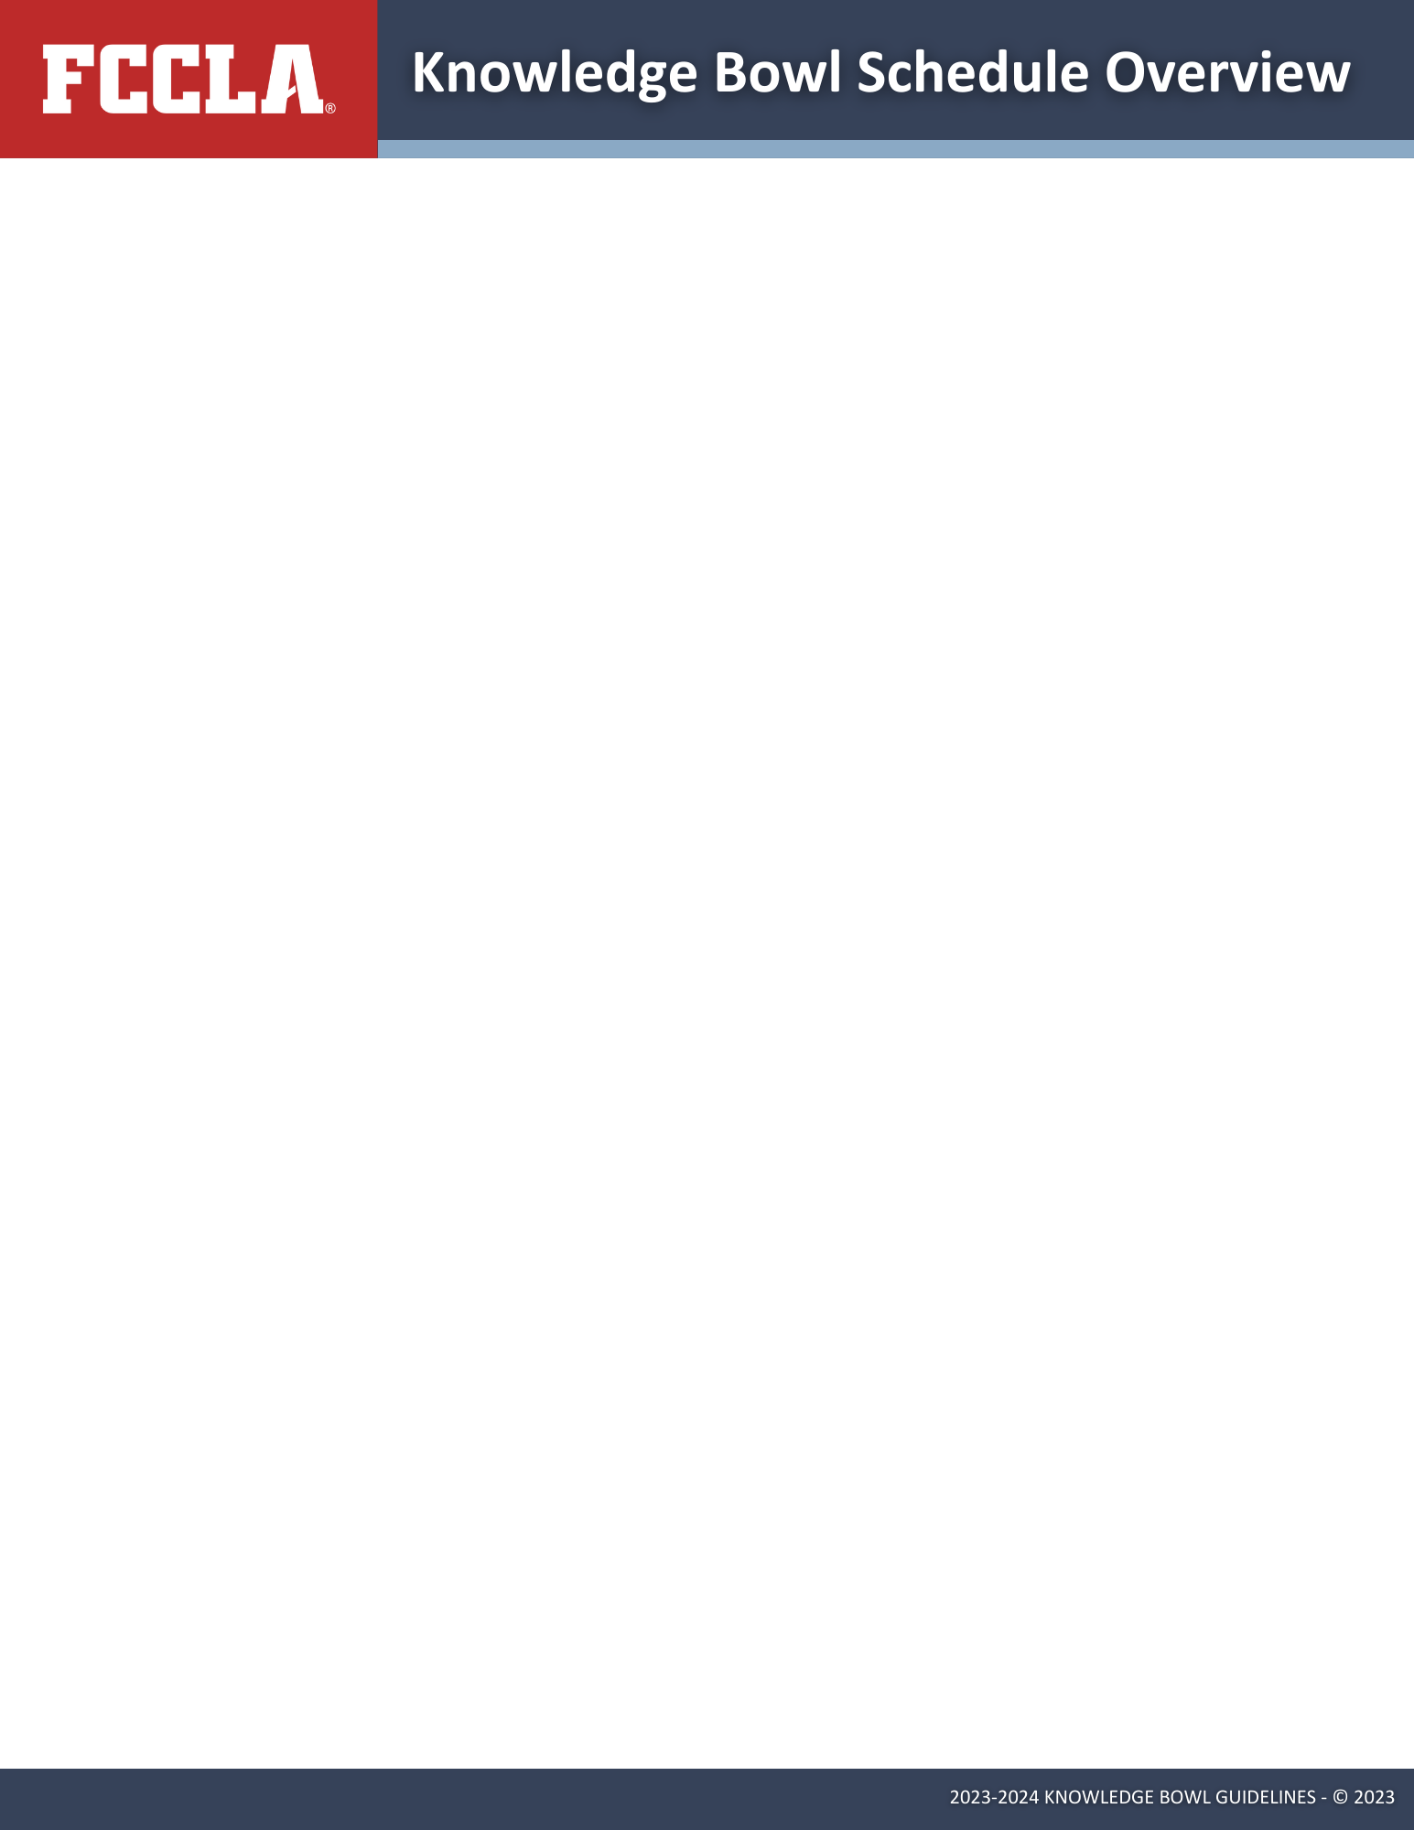

|  |  |  |  |  |
| --- | --- | --- | --- | --- |
|  | **Round I:**  **Direct Qualifying** | | **Round II:** | **Round III:**  **National Championship** |
| **Part 1 – Fall TeamSmarts NLC Qualifier**  **10/21-11/25, 2024** | **Part 2 – Top 40  posted /shared  on  Social Media** | **FCCLA Spring Knowledge Bowl TeamSmarts Quiz**  **3/1 – 3/31, 2025** | **National Leadership Conference**  **7/5 – 7/9 , 2025** |
| **Who?** | Any team of 5 FCCLA members *(must be affiliated)* | The top 40 teams from the Online Test | The 40 teams that advanced and teams 41-50 for substitution purposes | 40 teams |
| **Competition Process** | * Adviser creates coach account (or logs back in if previously registered) and registers team at <https://lifesmarts.org> or updates team(s) from previous year. * Students register and join the team and may take practice quizzes * Adviser appoints team captain * When test window opens, the quiz appears automatically in the captain’s **Quizzes** dashboard * Team captain leads team through Online TeamSmarts quiz * Top 40 Teams announced |  | * Adviser coach may substitute students on online team * Teams keep taking practice quizzes until window opens * When test window opens, quiz appears automatically in the captain’s folder * Team captain leads team through Online TeamSmarts quiz | **Orientation and Pool Play**   * Teams will be assigned to either morning or afternoon competition session * Teams seeded into 5 pools of 4, each team plays a buzzer match vs. the other 3 teams in their pool. * Scores accumulate, overall top-scoring team from each pool across both competition sessions advances to knockout bracket * The next 11 highest-scoring teams across all pools also advance to knockout bracket |
|  |
|  |
| -Top 16 teams seeded - |
| **Knockout Bracket**  Seeded teams play head-to-head until 2 finalist teams remain. Play-off for third place team. |
| **Who advances?** | All teams | 40 teams and alternate teams | 40 teams – score is first part of their NLC score | Two finalist teams play for the Championship during National Leadership Conference General Session |

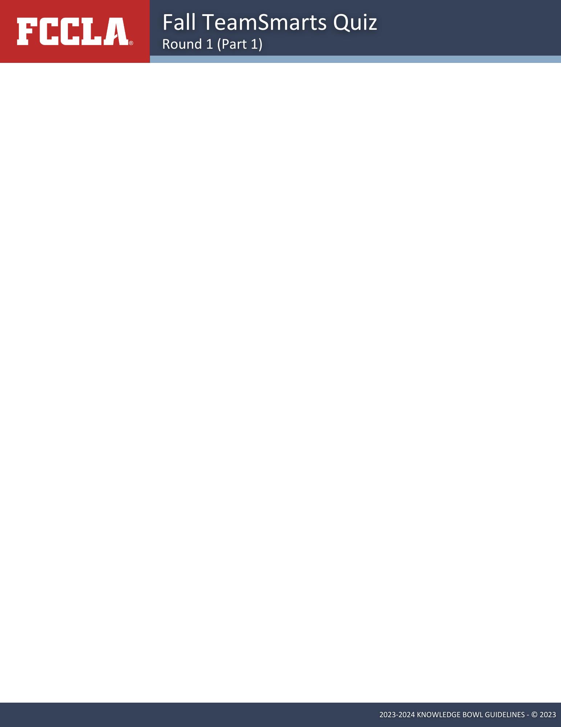

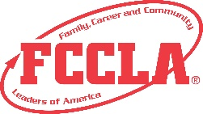

**Family, Career and Community Leaders of America®**

13241 Woodland Park Rd STE 100

Herndon, VA 20171

[competitiveevents@fcclainc.org](mailto:competitiveevents@fcclainc.org)

[www.fcclainc.org](http://www.fcclainc.org)

**LifeSmarts**

<https://lifesmarts.org/>  
[LifeSmarts@nclnet.org](mailto:LifeSmarts@nclnet.org)