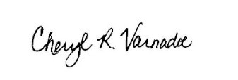
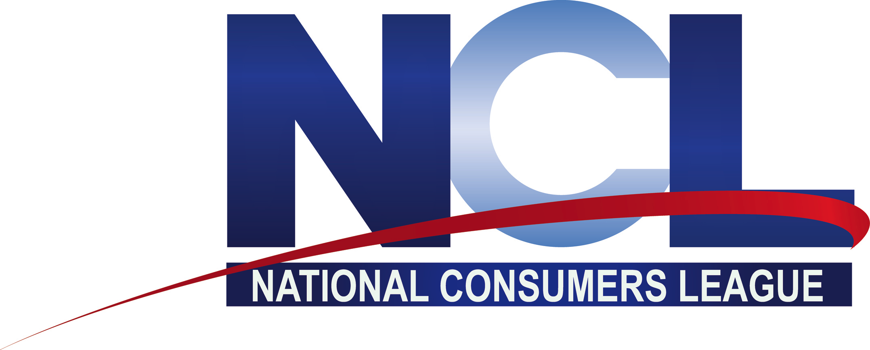

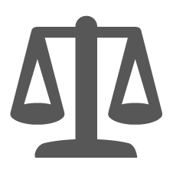

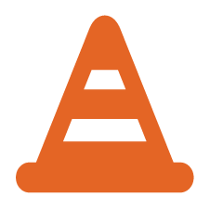

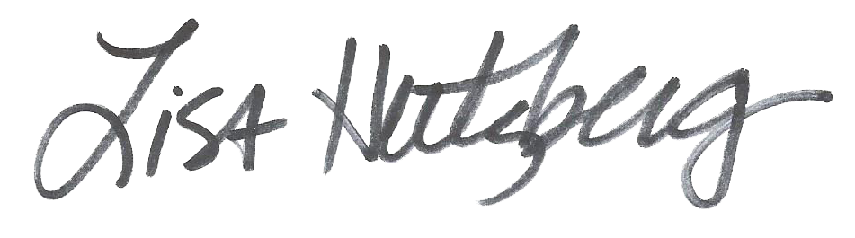
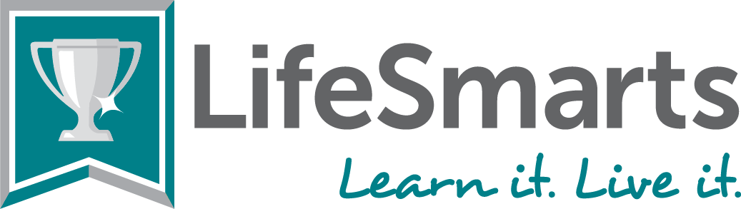

For demonstrating outstanding consumer smarts by attaining
a 20/20 perfect score in LifeSmarts quizzing in 2024

The LifeSmarts Program of the National Consumers League presents this
Certificate of Achievement
to

Lisa Hertzberg
LifeSmarts Program Director
Cheryl Varnadoe
LifeSmarts Outreach Coordinator

LifeSmarts Coach

