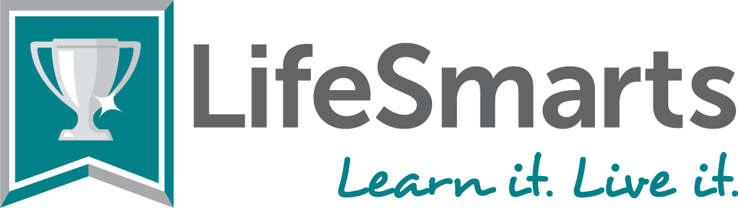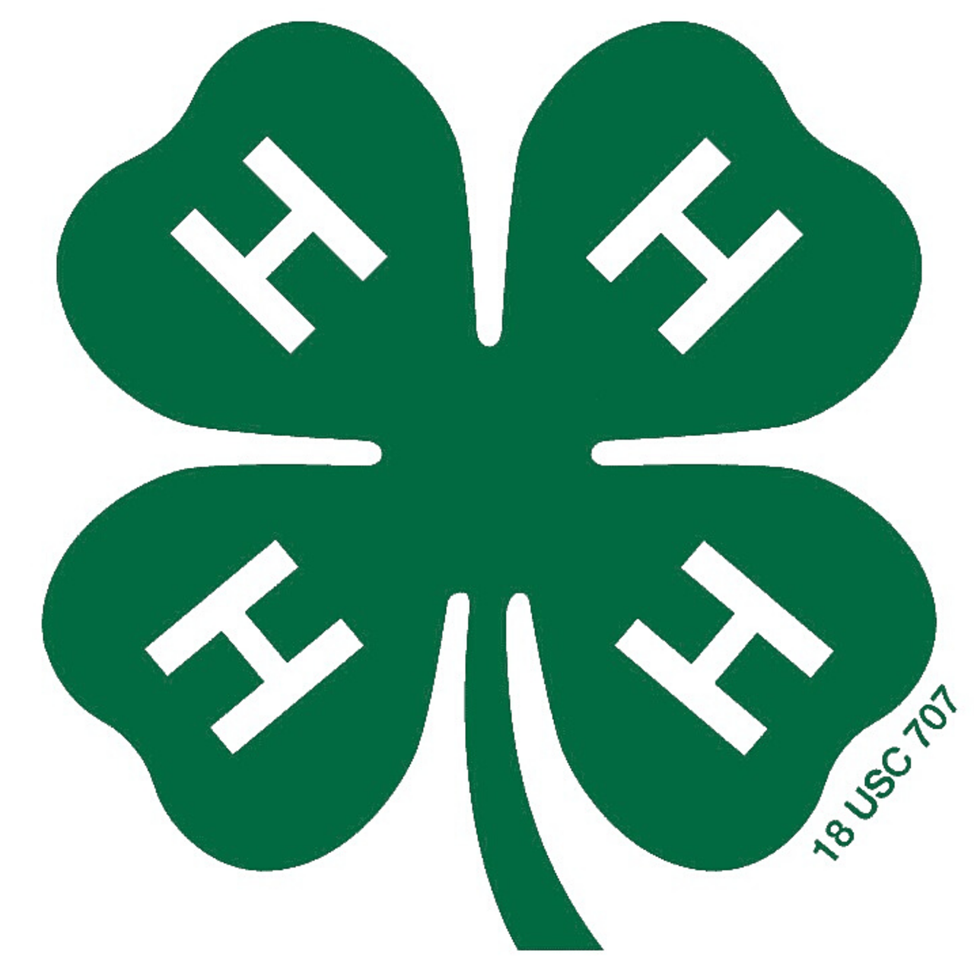  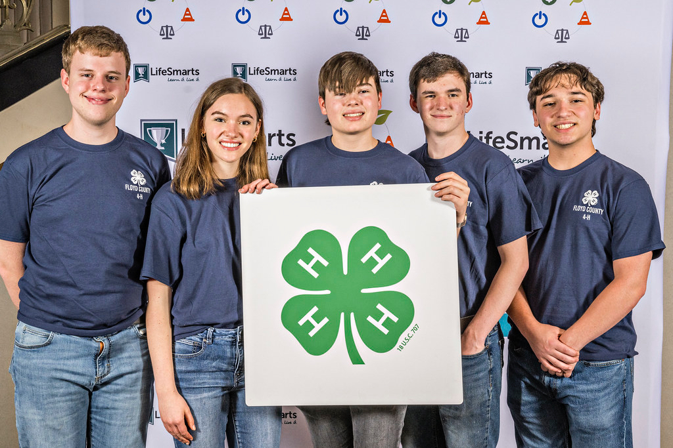  - LifeSmarts + 4-H =  Fun!  What is LifeSmarts?  LifeSmarts is an exciting, free, fast-paced consumer education program and quiz bowl style competition that prepares teens for real life. LifeSmarts provides educators and students with extensive resources, challenging competitions, impactful community service projects, and opportunities for achievement, awards, travel and scholarships. Use LifeSmarts to compliment as well as strengthen existing 4-H programs and projects, explore new opportunities and most of all… have FUN, all while learning by doing!  LifeSmarts categories are: Health & Safety, Technology & Workforce Preparation, Consumer Rights & Responsibilities, Personal Finance, and the Environment. 4-H’ers already learn about all five of these competition areas through Consumer Decision Making / Family and Consumer Science Judging / Quiz Bowl or Skill-a-thon, other 4-H judging and competitive events, 4-H project work, 4-H Healthy Living and STEM programs, community service…the list goes on and on!  LifeSmarts also has special opportunities just for 4-H teams including: TeamSmarts competitions complete with cash prizes, Wild Card team qualifications, the 4-H online Summer Challenge where 4-H teams can earn cash prizes, and more!  Get your 4-H’ers involved in LifeSmarts today and find out what so many  4-H’ers and 4-H programs across the country already know. Sign up today at https://lifesmarts.org and also visit our 4-H page at https://lifesmarts.org/4-h/.  . | The LifeSmarts/ 4-H Link  4-H Teams Can Compete in Monthly 4-H TeamSmart Challenges for Cash Awards!  State Winning Varsity LifeSmarts Team Advances to National in-person Contest! State winning JV teams advance to online Nationals. 4-H High School Teams are Varsity Teams and Middle School Teams are Junior Varsity Teams.  4-H Teams Receive Wild Card Bids to the National LifeSmarts Championship! (Usually several 4-H Teams receive bids!)  Use LifeSmarts lessons and resources for clubs, classes, workshops, leadership & service projects and more!  Lifesmarts  https://lifesmarts.org  Cheryl Varnadoe  National LifeSmarts Outreach Coordinator  National Consumers League  cherylv@nclnet.org  706-255-9342

