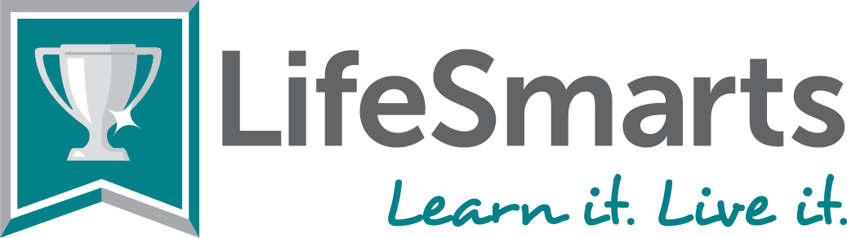
LifeSmarts and SkillsUSA Links and Handouts
Visit the website: https://lifesmarts.org/
SkillsUSA Coaches page: https://lifesmarts.org/skillsusa/
Coaches page: https://lifesmarts.org/coaches-2/new-coaches/
(many things here including LifeSmarts Coach’s Guide; Monthly Checklist Calendar; How to register and compete; How to LifeSmarts; links to our promotional videos; Promo Flyer and MORE!
Handouts:
- LifeSmarts Factsheet: https://lifesmarts.org/wp-content/uploads/2023/03/LS-fact-sheet-22-23.pdf
- How to LifeSmarts: https://lifesmarts.org/wp-content/uploads/2022/10/How-To-LifeSmarts_22-23-December-2022.pdf
- TeamSmarts prizes for SkillsUSA teams: https://lifesmarts.org/teamsmarts
- Talking Points for SkillsUSA: https://lifesmarts.org/wp-content/uploads/2023/03/Talking-Points-for-4-H-BPA-FBLA-FCCLA-SkillsUSA-and-Jumptart-Coalitions-12-14.pdf
- Health and Safety LifeSmarts Resources: https://lifesmarts.org/resources/resources-by-category-top-level/resource-links-by-category-health-and-safety/
- Get to Know LifeSmarts: https://lifesmarts.org/wp-content/uploads/2023/03/Get-to-know-LS-22-23.pdf
- Common Core Standards: https://lifesmarts.org/wp-content/uploads/2023/06/Common-Core-2023.pdf
- Six Reasons to Compete in LifeSmarts: https://lifesmarts.org/wp-content/uploads/2022/08/LS-5-incentives_20-21.png
- LifeSmarts in a Box: https://lifesmarts.org/resources/lifesmarts-in-a-box-teaching-toolkit/
- CEU’s for LifeSmarts Coaches: https://lifesmarts.org/ceu/

LifeSmarts Outreach Coordinator:
Cheryl Varnadoe
Cherylv@nclnet.org
706-255-9342

