Recommended Practice Content 2023

LifeSmarts covers content in five major areas. The LifeSmarts.org web site has many free educational resources, and we encourage you to use the entire site. However, we also want to help you bookend content and make the most of your team’s practice time. This guide will help you quickly find the most pertinent LifeSmarts resources.

- Competition resources
  - The LifeSmarts competition website has practice quizzes, re-opened TeamSmarts quizzes (more information below), and all students competing at Nationals must complete a series of qualifying quizzes (pre-quiz, five category quizzes, and the capstone) as soon as possible.
  - Retired Practice Rounds (updated questions coming soon)
  - Scrimmages – we will schedule a scrimmage for your team using Zoom and virtual buzzers. Your team will compete live against another Wild Card team to answer questions used in the 2023 State LifeSmarts Competitions.
  - LifeSmarts in a Box resource (great ideas to reinforce vocabulary and teamwork). Download the file
  - Quizlets, Live Quizlets, Kahoots, and much more – search for LifeSmarts on any of these sites.
  - Daily Quiz on the LifeSmarts home page. Five new questions every time you reload the quiz.
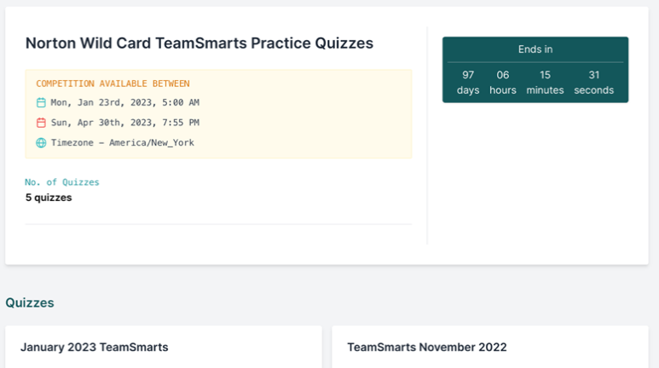
- Consumer Rights
  - Consumer Rights (November 2022) TeamSmarts quiz. 100 questions on consumer rights topics. Your captain has access to launch the quiz from the competition site. Your captain will see this folder when they login (Norton Wild Card TeamSmarts Practice Quizzes). The captain will click on the quiz your team wishes to review, and together they will answer this 100-question quiz. There is one for each topic area.

  - November 2022 question-a-day calendar
    - Calendar
    - Answers
  - Consumer Rights Vocabulary (see weeks 10-13)
  - LifeSmats U lessons
    - Financing Education
    - Counterfeit Products
    - Laundry 101
- Environment
  - Environment (January 2023) TeamSmarts quiz
  - January 2023 question-a day-calendar
    - Questions
    - Answers
  - Environment Vocabulary (see weeks 19-22)
  - LifeSmarts U lessons
    - Protect the Planet
- Health & Safety
  - Health & Safety (September 2022) TeamSmarts quiz
  - September 2022 question-a day-calendar
    - Questions
    - Answers
  - Health & Safety Vocabulary (see weeks 1-5)
  - LifeSmarts U lessons
    - Drug Facts Label
    - Medicine 101
- Personal Finance
  - Personal Finance (October 2022) TeamSmarts quiz
  - October 2022 question-a day-calendar
    - Questions
    - Answers
  - Personal Finance Vocabulary (see weeks 6-9)
  - LifeSmarts U lessons
    - Buying a Used Car
    - Credit Reports
    - Higher Education
- Technology & Workforce Preparation
  - Technology (December 2022) TeamSmarts quiz
  - December 2022 question-a day-calendar
    - Questions
    - Answers
  - Technology Vocabulary (see weeks 14-17)
  - LifeSmarts U lessons
    - Shop Smart Online

