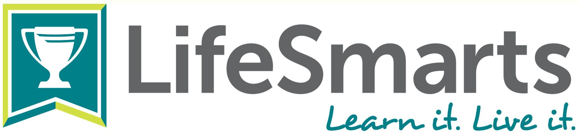

LifeSmarts, the nation’s premier consumer program, has been providing real-world education for more than 25 years. Operated by the National Consumers League, the nation’s oldest consumer advocacy organization, LifeSmarts is provided free to middle school students and educators. The program’s goal is to create consumer savvy young people who will be better equipped for adult life in today’s complex, global marketplace.

LifeSmarts State Coordinators
Partnering with LifeSmarts is an excellent way for organizations to demonstrate their commitment to educators, young people, consumer education and financial literacy. LifeSmarts is fortunate to partner with state-based agencies and organizations to run the program at the local level, including state Attorneys General, consumer protection agencies, Jump$tart Coalitions, Councils on Economic Education, Extension Agencies, 4-H leaders, credit unions, and more. Coordinators receive ongoing support from NCL which includes promotional materials, guidelines, competition scripts with questions and answers, and monthly conference calls.

The Role of a State Coordinator
Coordinators are free to design a state LifeSmarts program to meet their goals and best meet the needs of their students and educators. State Coordinators:
- Oversee the statewide LifeSmarts program
  - Serve as the state contact for coaches
  - Establish a LifeSmarts state program web site
- Conduct outreach
  - Market and promote LifeSmarts statewide to schools and other youth organizations
  - Recruit coaches, volunteers, sponsors and donors
  - Plan training sessions for coaches and teams in cooperation with the LifeSmarts staff
- Plan and conduct the in-person or online state LifeSmarts competition
- Fund the LifeSmarts program
  - Support the state winning team with ideas for raising funds and attending the national competition

What Coordinators Say about LifeSmarts
“I love hearing from previous LifeSmarts students how much they appreciate all the knowledge gained from LifeSmarts.” -Angela Howdeshell, Kansas Council for Economic Education
“I enjoy the whole process from recruiting schools and students, the classroom demonstrations, and of course the state and national competitions!”-Will Rance, Washington State Employees Credit Union

